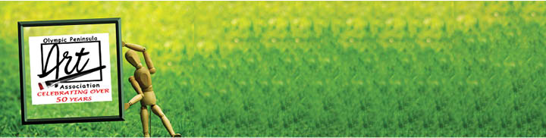
Mighty Minis 2023
Virtual Show and Fundraiser
June 15 - August 31

Instructions & Release Form

The Olympic Peninsula Art Association’s (OPAA) “Mighty Minis” Virtual Show & Fundraiser will showcase small artworks created and donated by artists. Artists do not have to be an OPAA member to donate their artwork. Each artwork should be 5 x 7” or smaller. These artworks are to be exhibited in a virtual format, and be signed by the artist. There is no entry fee, and all artwork donations will be accepted, exhibited and be for sale to the public for $25 each. The artwork donations must be received by May 31st to be exhibited in the show & fundraiser from June 15th through August 31st. OPAA is a 501(c)3 non-profit organization dedicated to promoting visual arts in the community. The money raised will be used to provide Scholarships, support art programs on the peninsula, and fund other non-profit projects OPAA assists throughout the year.

All media will be accepted for this show. However, the size is limited to an artwork that is 8” x 10” or less. OPAA is asking artists to back 2-D artwork with foam core or matboard to protect the art. Artworks may be (not required) matted/framed, but the artwork with mat/frame must not be larger than 8” X 10.” Small 3-D artwork is welcomed. Artwork is to be signed, and meet the “Mighty Minis” size limits.

All artwork will become the property of Olympic Peninsula Art Association. OPAA reserves the right to photograph and use images of artwork on their website, newsletter, and in promotional material for the purposes of documentation and publicity. OPAA shall have the right to use the artist’s name in connection with all advertising & promotional materials regarding OPAA. Artist shall retain all 17 U.S. § 106 copyrights in all original works of authorship.

Olympic Peninsula Art Association would like to thank you for your support in donating artwork for our fundraiser. Please bring artwork to the May 25th OPAA General Membership meeting in at Harmony Center 223 Hudon, Sequim WA; OR drop-off artworks at the Blue Whole Gallery, 129 Washington St, Sequim; OR mail your artwork to OPAA “Mighty Minis”, PO Box 1842, Sequim, WA 98382. The Blue Whole Gallery is open Mon – Sat., 10 am-5:00pm.

Artwork donations must be received no later than May 31st with a signed release form (page 2) to be a part of this show. If you have questions please email: opaapresident2023@gmail.com or call Debbie Young at 602-309-2742 and leave a message.

Release Form on page 2.

Please complete the following Release form for each artwork donated. A receipt will be returned to you for your records.

Please Print:

Name: Click or tap here to enter text.
Address: Click or tap here to enter text. City: Click or tap here to enter text. State: Click or tap here to enter text. Zip: Click or tap here to enter text.
Email: Click or tap here to enter text. Phone: Click or tap here to enter text.
Title of Piece: Click or tap here to enter text.
Medium: Click or tap here to enter text.
I have read and agree to the conditions & instructions for the OPAA “Mighty Minis 2023” Show & Fundraiser:
Signature of artist donor: Date: Click or tap here to enter text.

Please Print:

Name: Click or tap here to enter text.
Address: Click or tap here to enter text. City: Click or tap here to enter text. State: Click or tap here to enter text. Zip: Click or tap here to enter text.
Email: Click or tap here to enter text. Phone: Click or tap here to enter text.
Title of Piece: Click or tap here to enter text.
Medium: Click or tap here to enter text.
I have read and agree to the conditions & instructions for the OPAA “Mighty Minis 2023” Show & Fundraiser:
Signature of artist donor: Date: Click or tap here to enter text.

Please Print:

Name: Click or tap here to enter text.
Address: Click or tap here to enter text. City: Click or tap here to enter text. State: Click or tap here to enter text. Zip: Click or tap here to enter text.
Email: Click or tap here to enter text. Phone: Click or tap here to enter text.
Title of Piece: Click or tap here to enter text.
Medium: Click or tap here to enter text.
I have read and agree to the conditions & instructions for the OPAA “Mighty Minis 2023” Show & Fundraiser:
Signature of artist donor: Date: Click or tap here to enter text.

